[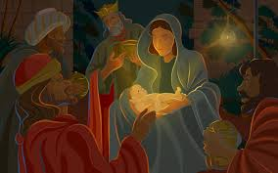](http://www.google.ie/imgres?imgurl=http://1.bp.blogspot.com/-A3i0-Dec2n0/TumUa7BmwpI/AAAAAAAABac/rQdSpFQ824c/s1600/nativity-scene-the-birth-of-jesus.jpg&imgrefurl=http://christmas-desktop-wallpapers.blogspot.com/&h=1000&w=1600&tbnid=hqKQ9GjKpdXaSM:&zoom=1&docid=z-9b-9SKl8LWXM&ei=8OeaVKPuOMmPaM2OgOAF&tbm=isch&ved=0CF4QMyhWMFY4ZA&iact=rc&uact=3&dur=7516&page=9&start=184&ndsp=24)